COMPANY DATABASE:

DEPARTMENT TABLE:
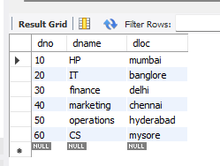

EMPLOYEE TABLE:

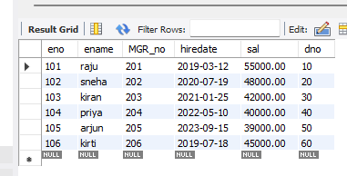

PROJECT TABLE:
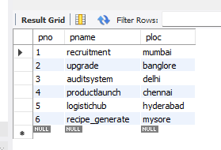

ASSIGNED_TO TABLE:
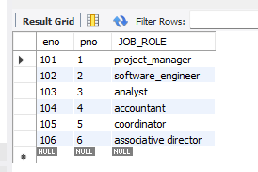

INCENTIVES TABLE:
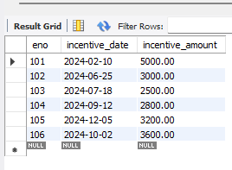

Querries:
Employee number of all the employees who work on project located in – BANGLORE ,HYDERABAD, MYSORE.

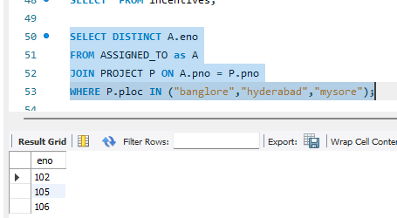

Get employee ID’S of those employee who didn’t receive incentives

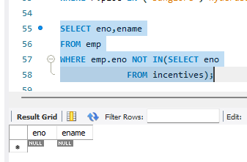
Employee details who are working for a project location same as his department location

